**ATA Cooled, Antonio Feed**

**Operation and Installation Manual**

**Matt Fleming, Minex Engineering, Ver 01**

|  |  |  |  |
| --- | --- | --- | --- |
| Version | Date | Comment | Initials |
| Ver 00 | 2014-11-08 | Preliminary framework. | MCF |
| Ver 01 | 2019-03-17 | Incomplete, but 1st distribution. | MCF |
| Ver 02 | 2019-04-03 | Added Troubleshooting. ( preliminary ) | MCF |

**Contents**

[Introduction: 2](#_Toc5277457)

[Safety Issues to Understand for the glass dome: 2](#_Toc5277458)

[Description of the device and its operation: 3](#_Toc5277459)

[Sunpower: 10](#_Toc5277460)

[Assemblies & Sub Assemblies: 10](#_Toc5277461)

[Installation: 11](#_Toc5277462)

[Typical operations and performance: 12](#_Toc5277463)

[Troubleshooting and Diagnostics ( incomplete ) 14](#_Toc5277464)

|  |
| --- |
| Figure 01 |

~

# Introduction:

These instructions should be read along with the following documents:

ATA Cooled Feed Manual Control Commands.

ATA Cooled Feed Development History.

This document will give information on the operation, installation and maintenance of the ATA Cooled Feed. Please note the Safety Issues Section on this document for priority reading. This feed design was originally started with funds from the SKA TDP program in 2010. The current design identified as 5C4, has gone through several iterations. Information on the various designs leading to the current design can be found in a separate document. Some highlights of the design are listed below.

* Frequency range 0.9 to 14 GHz.
* Noise temperatures of 21 K at 2 GHz sloping to 60 K at 14 GHz measured on the telescope September, 2014.
* LNA & feed arms are cooled to between 65 and 70 Kelvin.
* The Vacuum chamber is under a Borosilicate glass radome at about 1.0 E-6 mbar.
* Vacuum is maintained by Pfeiffer Hi Pace 80 turbo pump and Diaphragm pump.
* Cooling is provided by Sunpower GT sterling cycle cooler.

# Safety Issues to Understand for the glass dome:

The ATA Cooled Arm Feed uses a glass vacuum tight dome similar to a large bell jar. The glass is thin at the end, about 1mm thick. There is a risk of explosive disintegration and flying glass, if the glass is impacted with enough energy to cause fracture. Whenever the Radome is under vacuum please follow these basic guidelines:

* Keep the foam cover and containment bag in place whenever possible. ( no excuses )
* If the cover is removed any nearby personnel should wear protective clothing, gloves and a face shield.
* Even when the pump is not operating the vacuum can hold for many days.
* Distributed pressure can be applied to the cylindrical portion of the radome near the base.

The radome is a Pyrex type glass tapered down to a 76mm = 3 inch radius hemisphere and the glass thickness also tapers from 5mm = 0.196 inches at the base to 1.5mm = 0.050 inches at the tip. The entire shape is compression loaded by atmospheric pressure at about 15 psi and is quite strong. However, an impact from a sharp heavy object would most likely break the glass. Glass particles would be accelerated by decompression or disintegration and would be dangerous to personnel nearby. Without containment, it is estimated that glass particles 1 inch square and larger can be thrown up to 20 feet during disintegration, and smaller particles may go further. For this reason the radome is covered by a 1/4 inch thick layer of firm RF transparent foam and a heavy duty bag made from RF transparent fabric. Basically, with the covering in place, a 6 inch adjustable wrench dropped from 3 feet on an area near the tip would probably not fracture the glass, however a 10 inch adjustable wrench dropped from the same height and location might have enough energy to cause fracture and disintegration of the tip area. No glass would escape if the covering was installed correctly. The feed can be handled and supported from the radome, but support load should be distributed as is typically the case with one’s hand or arm. If one needs to apply support to the radome, use the cylindrical heavier wall part of the dome, not the thinner tapered section.

# Description of the device and its operation:

The ATA Cooled Arm Feed is a log periodic type design. The feed is part of a receiver system. The term feed refers to the portion of the system that actually collects the radio signal and “feeds” it to the first of several stages of amplification. In this section we will describe the basic hardware of the unit and then how the system works from the point of view of the signal path, Vacuum system and cooling system.

Hardware Description: The heart of the feed is an all copper four sided pyramid with 20 degree opening angles. The four pennant arms are also copper and suspended over each side of the pyramid by several rexolite plastic plates. The LNAs are mounted inside the pyramid. The copper structure is supported on 4 titanium standoffs about 1.00” long that have been bored out to leave only a 0.009” thick wall thickness. The Dewar base plate is made from precision machined 3/4 thick 304 stainless steel. A 2.00” diameter NW-50 flange is welded in for the cryo cooler and an offset 2.00” tube with a 1.50” NW-40 has been welded in for the turbo pump. The Dewar Base is bolted to an aluminum chassis which houses the Turbo pump, diaphragm pump cryo-cooler, cryo control board, feed control board circulation fan, input power filters. Many of the electronic items in this space emit EMI & RFI noise that would affect the low frequency performance of the feed and for that reason the housing has welded joints and metal mesh gaskets around all connections to other parts of the system. The integrity of these gaskets is critical. The power line filters are present to prevent any signals generated inside the housing from being transmitted out on the input power cable. It is essential for the cryo cooler heat rejection fins to have air flow. Never operate the cooler without air flow for more than about 2 minutes without some air flow. The rejection heat sink should not exceed xx C. The turbo pump also has a requirement for air flow. However, it is less sensitive and can operate for 30 minutes or perhaps longer with simple convection. The diaphragm pump is similar. Fortunately the Housing is designed in such a way that air flow through the cooler is unchanged even when the cover is removed from the side of the housing. The air flow system is power with a centrifugal blower with the suction end pulling air from inside the housing across the cryo rejection fins and the exhaust air exits the side of the housing through a honeycomb EMI vent. The system has two air intake sources. One source is pulling air from the PAX case as it exits beneath the PAX TEC Cooling fins. This air supply originates at the Zone node house travels through the entire antenna and will have a fairly stable temperature. The other source is outside ambient air drawn through a honeycomb EMI vent in the bottom of the housing. This inlet is equipped with a dust filter and must be cleaned or replaced occasionally for proper operation.

Signal Path Description: This feed has a hollow copper, 4 sided pyramid core about 21 inches long with faces 10 degrees apart. There are four tapered pennant style feed arms suspended above each pyramid face, forming a 20 degree angle. The upper and lower arms collect the X polarization and the right and left side arms collect the Y polarization. The signal from each arm is fed at the small end of the arm onto a very small diameter coax cable which routes the signal to the interior of the pyramid. This is where the four signals encounter the first of several levels of amplification. These first amplifiers are called the LNAs or Low Noise Amplifiers. The X pole LNA accepts the two cables from the upper & lower arm and outputs the amplified combined signal on a single coax cable. The Y pole is handled in the same way by a second parallel LNA. The two output polarizations then pass via coax cables through the housing behind the feed to the next stage of amplification. These amplifiers are called the PAMs = ( Post Amplifier Modules ). The signal then exits the PAMs and enters the, transmit or driver, side of a fiber optic link from the antenna to the Correlator Building. The PAMs and fiber drivers are housed in the PAX = Post Amp Box. The PAX also contains a control board that provides proper supply voltages to the LNAs, PAMs and Fiber Drivers. The portion of the receiver system just described is all located at the antenna is called the “Front End” and the portion of the receiver system that is at the Correlator is called the “Back End”.

Cooled Components Description: In order to attain a high signal to noise ratio for a collected signal, the LNA must be cooled to cryogenic temperatures, the colder the better. In fact all components in the signal path ahead of the LNA also benefit from operation in a cooled environment, particularly the very small coax connected to each pennant arm. For this reason it is desirable to cool the entire pyramid and feed arm structure as well as the LNAs. The LNAs are positioned inside the pyramid as close as possible to the tip of the arms. In order to cool the entire copper feed structure it must be isolated from heat sources. This structure is affected by 3 types of heat transfer from the environment: 1) convection of air around the copper, 2) conduction by solid materials in direct connection to the feed, 3) radiation onto the feed exposed surfaces. The glass radome over the entire feed creates a chamber that can be evacuated to reduce heat transfer by convection. In the world of vacuum systems there are low, medium, high and ultra high vacuum categories. We need to operate at the high vacuum level of 1.0 E-6 mbar or better to prevent molecular heat transfer by way of gases. Conduction is reduced to a minimum by supporting the heavy copper feed structure on extremely thin walled titanium standoffs. Titanium is chosen because it is very strong and a very poor thermal conductor. The coax from the LNA to the Dewar Base are another source of direct conduction, so the outside jacket is made from stainless steel which is also a poor thermal conductor. The electrical connections to the LNA area is the last source of conduction load so they are made as small as possible and in some areas copper phosphor bronze wire is used. It is important not to reduce wire size too much or excessive voltage drop may occur. The final type of heat load is from direct radiation. Direct radiated load from the ground or other non reflective surfaces is about 300 Kelvin. When install in an ATA antenna the feed looks out to metal surfaces that eventually reflect to the sky. The sky is actually quite cold from a thermal radiation point of view. This is why it is important to close the feed access doors on the lower side of the antenna shroud. The most important defense against radiation load is to guarantee the copper surfaces are clean and presenting a very low emissivity of about 0.3 or less. Essentially the copper surfaces are reflecting away a high fraction of an incident thermal radiation.

Vacuum Components Description: The vacuum chamber for the feed is composed of a Stainless steel base plate and a glass dome with a double o-ring seal at the base. The radome must be very transparent to radio signals, so at the high frequency end it is about 1mm thick, and it must be strong at the base so it is about 5mm thick at the flange. It is also very important that that the dome be very transparent to thermal radiation as well. This is why some materials like fiber glass will not work for the radome. Fused quartz glass is perhaps the best material with a dielectric constant of 3.8 but it is more expensive and very hard to form. We have chosen borosilicate glass with a dielectric constant of 5.1 for economy. The roughly 12” diameter dome is compressed onto the base plate by atmospheric pressure generating about 1,600 lbs of force.

The only way to maintain high vacuum levels like 1.0 E-6 mbar is to have extremely clean surfaces inside the chamber space. A single finger print can outgas for many days causing many days of pumping before an adequately high vacuum is achieved. It is usually advisable to bake out the vacuum system to accelerate pump down time. In general as ambient temperature rises items inside the vacuum chamber outgas faster and the pressure usually rises in proportion to the temperature. In general a design should reduce the use of plastics as much as possible inside the vacuum space. O-ring seals are another source of gas leaking into the system either by leaking or by permeability. All polymers will allow some level of permeability. If proper o-rings are selected and all mating surfaces are clean, they will not cause an unacceptable gas load.

Maintaining the feed at 65 Kelvin is one of the toughest requirements for the feed. When a large copper surface is cooled to 65 Kelvin there are several gas molecules that will want to condense onto the cold surfaces. H2O, CO2, N2 and so on, are all molecules that will condense onto these cold surfaces. When enough of this occurs the emissivity of the copper may be affected. This will reduce the ability of the surface to reflect away thermal radiation load. We are using a Sunpower GT cryocooler which can lift away about 10 watts of heat load at 65 Kelvin. As the copper surface emissivity is reduced, the load on the cryo cooler increases. At some point the cooler will reach the maximum electrical input power limit of 240 watts, and the feed temperature will begin to increase.

|  |
| --- |
| Figure 02 |

|  |
| --- |
| Figure 03 |

|  |
| --- |
| Figure 04 |

|  |
| --- |
| Figure 05 |

|  |
| --- |
| Figure 06 |

|  |
| --- |
| Figure 07 |

|  |
| --- |
| Figure XX |

|  |
| --- |
| Figure XX |

# Sunpower:

For an ambient condition of operation the cooler can operate from -40 C to 60C.

First, the limiting feature for temperature is the bobbin material that holds the alternator wire. We assume it operates 10-15 degrees hotter than the surface temperature of the pressure vessel (location of the label), so we tell customers not to exceed 70-75C at the surface. This gives some margin on overheating the alternator. This would be for the sensor on the main PV of the cooler, near the balancer.

For a short time you can probably get away with a higher temperature as long as the bobbin isn't getting over 100C, but that isn't something that can be measured to know exactly what outside temperature means you're at the limit temperature of the bobbin. Plus this is a combination of the temperatures of both your sensors so there isn't a specific value to use as a limit.

At the reject area, where the fins are located, the copper should not exceed 60C. Running clearances are the main concern at this location but there are dynamic issues as well. It is a good idea to use the forward heat sink as the rejection shut down alarm.

I've attached a Powerpoint slide that shows the heat flow of the coolers to know the portions and the approximate amount of heat being expelled from the various parts. It's always best to be conservative with your reject alarms with these machines.

From: Cliff Fralick [mailto:Cliff.Fralick@ametek.com]

Sent: Tuesday, July 07, 2015 10:53 AM

# Assemblies & Sub Assemblies:

Below is a top level listing of assemblies and subassemblies used in the ATA Cooled Feed. Some additional related Parts and Tools are also listed. This is presented just to give an overview of how engineering design models and drawings are organized. There are well over 200 custom fabricated and purchased parts in each Feed.

|  |  |
| --- | --- |
| MEC Part Numbers | Description. |
| 30-29-200 ATA Cooled Feed. | Top Level Assembly. |
| 30-29-180 Lens. | Made from polyethylene, about 1mm think and intended to have a 4mm gap. |
| 30-29-190 Foam & Fabric Cover. | Foam & fabric cover, essential for safe use while under vaccum. |
| 30-29-202 Radome Glass | Made from Duran borosilicate glass, 300 x 5mm tube at base, tapering to 150 radius x 1.5mm thick dome, |
| 30-29-210 Dewar Base | Machined 304 stainless steel plate 0.75 x 13.00” diameter. |
| 30-29-230 Feed arms & pyramid | Pyramid22.4” tall, 4.00” square base |
| 30-29-520 LNA Module Assy | Manufactured by Low Noise factory ( LNF )  input via two 0.031” coax clamped in place. Biasing via Nano D connector, 9 pins 4 used. Typical identifier LNF-ABLNC1\_15A sn0001A |
| 30-29-280 Turbo Pump & Controller | Turbo pump, Pfeiffer Hi-Pace-80, with attached 110 control electronics, 1.50” NW flange input, 24VDC, xx amps 24, requires some minimum level of convection cooling, backing pump connection NW-16 flange. Should maintain 1.0E-6mbar vacuum with 10 to 15 watts of input power. |
| 30-29-290 Cryo Cooler Assy. | Sunpower GT Cooler and mounting parts. |
| 30-25-200 Rail System. | Rails to help support to new feed on existing 30-25-100 Focus Device. |
| 30-26-310 Power Supply at Rim Box. | The 48 VDC supply and switches for the Dish Rim Box. |
| 30-27-600 Electronics & cables. | Partial documentation for boards, cables and connectors. |
| 30-29-Tool Feed Power Supply. | Portable 24 & 48 VDC supply. |
| 30-29-Tool Feed Assembly Stand. | Rolling stand for Feed assy and testing. |
| 30-29-Tool Hot Load. | For noise testing. |
| 30-29-Tool Cold Load. | For noise testing. |

# Installation:

The ATA Cooled Arm Feed mounts on the same focus mechanism as the older ATA Ambient Arm Feed, however the 5C design requires additional support from below with a special rail system. This rail system, shown in photo 1, must be aligned with the stroke of the focus mechanism. This can be most easily done by positioning the antenna at the lowest elevation about 18 degrees. The focus actuator shafts should be very parallel to the top surface of the focus mechanism. Place a protractor level of decent accuracy on this top surface and set the level and lock it. Then place the level on the gray anodized slide track of the rail system. Loosen and adjust the end height of the rail. The end of the rail attached to the lower edge of the dish is not adjustable. Install assembly 30-29-450 support portion of the feed housing onto the rails. Make sure it can slide smoothly. Then install the feed attaching it to focus mounting plate and resting it on the previously installed Housing Support. This process is delicate and will probably take 2 people. A lifting tool is now available which can be lift the feed into position for attachment to the focus mechanism.

~

# Typical operations and performance:

The ATA Cooled Arm Feed operates about the same in vert & horz orientations. Cool down takes about 7 hours, 1 hour to get good vacuum and 6 hours to cool down to 65K at the cold head. Below is a short summary of a typical cool down sequence, assuming ambient 25C, fan at 60% and fairly clean system with no leaks.

|  |  |  |  |  |  |  |  |
| --- | --- | --- | --- | --- | --- | --- | --- |
| Time  ( hh:mm ) | vacuum  ( mbar) | Tubo  ( w ) | Motor  ( C ) | Cooler  ( w ) | Head  ( K ) | LNA  ( K ) | Comments |
| 0:00 | ------ | ------ | 25 | ------ | 298 | 298 | Diaphragm pump start. |
| 0:15 | 3.9 E+2 | ------ | 25 |  | 298 | 298 | Guage start. ( auto ) |
| 1:00 | 3.5 E+0 | 0 | 25 |  | 298 | 298 | Tubo start. |
| 1:03 | 7.8 E-4 | 77 | 64 |  | 298 | 298 | Turbo building speed, max power. |
| 1:05 | 9.3E-5 | 13 | 48 |  | 298 | 298 | Tubo at speed. Diaphragm low. |
| 1:15 0.0hr | 3.9E-5 | 13 | 40 | 35 | 298 | 298 | Cooler start. |
| 3:15 2.0hr | 1.3 E-5 | 13 | 37 | 190 | 144 | 175 | Cooler progress, largest gradients. |
| 5:15 4.0hr | 1.2 E-6 | 13 | 37 | 240 | 85 | 100 | Cooler at max power. |
| 6:45 5.8hr | 4.8 E-7 | 13 | 37 | 240 | 67 | 85 | Cooler ramping down. |
| 7:15 6.3hr | 4.8 E-7 | 13 | 37 | 180 | 65 | 82 | Cooler regulating. |

Do not allow cooler temperatures to exceed 70 to 75C.

Gauge begins reading between 4.8 E+2 and 2.8 E+2 mbar. If the Turbo is running above 30 watts, there is a pretty big leak. If the Turbo is running 9 watts then there is excellent vacuum near 6.7E-8 and a very clean system. With ambient at 25 Fan at 100% p326 44C or ambient 27 fan 60% p326 48C. Turbo at 90k rpm 6.6E-8 and 9 watts territory, below 30,000 rpm 1.0E-2 territory, Fan speed makes a small difference. If started at 1.0 E1 turbo will take 10 minutes to reach speed. If started at 1.0 E-1 turbo will take 3 minutes. Turbo takes about 9 minutes to wind down. It generates its own power for about 8 minutes. Without cryo running the turbo can get down to 2.8 E-6 mbar at 15 watts in 7 hours. It takes 6 hours before all parts are above freezing and 10 hours to ambient. mounts on the same focus mechanism as the older ATA Ambient Arm Feed, however the 5C design requires additional. Venting the chamber will run turbo up to 2400 rpm, never crack ball valve more than 45 deg. Have seen 65K and 157watts during 24C. Turbo 7 watts = 0.28 amps, 1.5E-5mbar, 10w 0.38 amps, 15:14 p316 47 p310 000219 = 2.19 amps

2015-05-04 15:07 -------------good plot startup issues.

15:07 got power 0, speed 0

p010=1

15:12 p316 started reading.15:15 48 2.25

15:16 50 2.32

15:22 58 2.73?

15:26 63 3.01

15:28 66 3.18

15:31 73 3.56

15:33 76w 3.74amps

15:35 76 3.75 ,326 52, 330 45,342 51, 346 99.

15:44 55w 2.54a, 326 54, 330 48, 342 57 346 88

|  |  |  |  |  |  |  |
| --- | --- | --- | --- | --- | --- | --- |
| 0 |  |  |  |  |  |  |
| 0:05 |  | 0w | wa |  |  |  |
| 0:08 |  | 48w | 2.25a |  |  |  |
|  |  |  |  |  |  |  |
|  |  |  |  |  |  |  |
|  |  |  |  |  |  |  |
|  |  |  |  |  |  |  |
|  |  |  |  |  |  |  |

~

# Troubleshooting and Diagnostics ( incomplete )

Feed is producing an audible loud vibration.

The Cooler is not functioning properly.

The Diaphragm pump or D-pump is not functioning properly.

The Fan is not functioning properly.

Feed Radome shows ice or is cold relative to the base plate and other parts of the feed.

A vacuum leak is present, Turbo pump power should be high or other Vacuum problem.

LNA temp is on target, and the cooler is operating at less than full power.

Everything is operating properly. ( it is probably not a hot day )

LNA temp is excessive, and the cooler power is at the maximum. ( example 240 watts )

Cooler heat rejection temp is excessive. ( see that section )

Inadequate vacuum creating high thermal load. ( see T-pump sections )

Cooler is malfunctioning. ( possible connector problem )

LNA temp is excessive, and the cooler power is below maximum. ( example 180 watts )

Cooler is in the process of a cooldown and is limiting max power as designed.

Cooler control has been set to power mode or max power has been limited by command.

LNA temp is excessive, and TTARGET is not set at the expected level.

Set it to 65K. ( determine why it was set higher before changing )

LNA temp is excessive, and the Cooler is not operating.

The 48VDC may not be present. ( the 24 VDC must also be present )

The Cooler or Control may have an error condition.

The thermostat open or soft-stop input circuits may be active.

The cold head temp is not lower than the LNA temp. ( we expect a gradient of 4 to 10 K )

There may be a problem with the LNA temp or cold head sensors.

The unit is warming up.

Cooler heat rejection or housing temp is excessive.

Duct cover over heat rejection fins is not in place.

Fan is not functioning properly due to improper control.

Fan is not functioning properly due to a mechanical problem. ( rubbing or jammed )

Inadequate air flow due to dirty restrictive lower air filter or jammed PAX air source.

Incoming air is already at an excessive temperature and unable to accept more heat.

Note: a breeze can quickly reduce ambient air temp in the shrouded area of the antenna.

Turbo or T-pump has excessive temperatures. ( normally cooler is more sensitive )

Feed enclosure cover is not in place and air flow is inadequate. ( usually not a problem )

T-pump is drawing excessive power. ( see T-pump power section )

Bearing temp is excessive due worn bearing. ( replace after 5 years )

Bearing temp in excessive due to D-pump problems. ( see that section )

Bottom temp is excessive due to excessive gas loads or D-pump problems. ( see that section )

Turbo or T-pump is drawing excessive power.

The pumping system has just started and is still developing adequate vacuum and rotor rpm.

Chamber has a leak. ( this usually increases with time and is less dependent on ambient temp )

Severe outgassing is occurring. ( this is often in proportion to ambient temp )

Diaphragm or D-pump is not functioning properly. ( see that section )

Motor is hunting, 90,000 rpm +/- 600 improper PID servo loop parameters. ( restart Turbo )

Diaphragm or D-pump has inadequate performance.

Contaminated with water vapor. ( run with open input line for a few minutes )

Pump valves are worn and need replacement. ( replace valves every 1.5 years )

Pump bearings are damaged. ( usually very noisy ) ( replace and rebuild unit )

One can set the D-pump to run at high speed to enhance performance until repair is possible.

Notes:

A D-pump is usually a field replaceable component.

A T-pump is usually a field replaceable component with proper training.

A T-pump takes 10 minutes to wind to a stop and it generates power for 2 minutes.

A T-pump rarely produces an audible vibration that can be felt with a finger.

A T-pump can be blow oil into the chamber if shut down or vented improperly.

An LNA temp sensor diode is not a field replaceable component.

A cold head temp sensor might be a field replaceable component with proper training.

A cooler can be a field replaceable component with proper training and tools.

**Diaphragm pump noisy**, means that pump rotational bearings are degrading and failure will occur sooner than later. It does not necessarily mean the pumping performance is degraded. Diaphragm pump performance can degrade if chambers get overloaded with condensed water or water vapor. These pumps sometimes struggle with water vapor more than other pump designs. This issue can be improved by opening the input of the pump to the atmosphere or clean gas for a good flow rate through the pump to carry away water.

~

|  |
| --- |
| Photo X: Feed 5C4 on lab bench with panel removed. |
| Photo X: Feed 5C4 on antenna and retracted for focused at high frequency. |

|  |  |
| --- | --- |
| IMG_8435.JPG  Photo X: Hot load temp 289 K. | IMG_8437.JPG  Photo X: Hot load in place. |
| IMG_8443.JPG  Photo 5: Equipment setup | IMG_8441.JPG  Photo 6: typical sky in pointed direction |
| DSC05246.JPG  Photo 7: Typical output routing thru special amps | IMG_0468.jpg  Photo 8: Typical output routing thru standard PAM. |

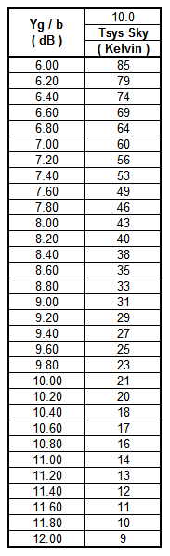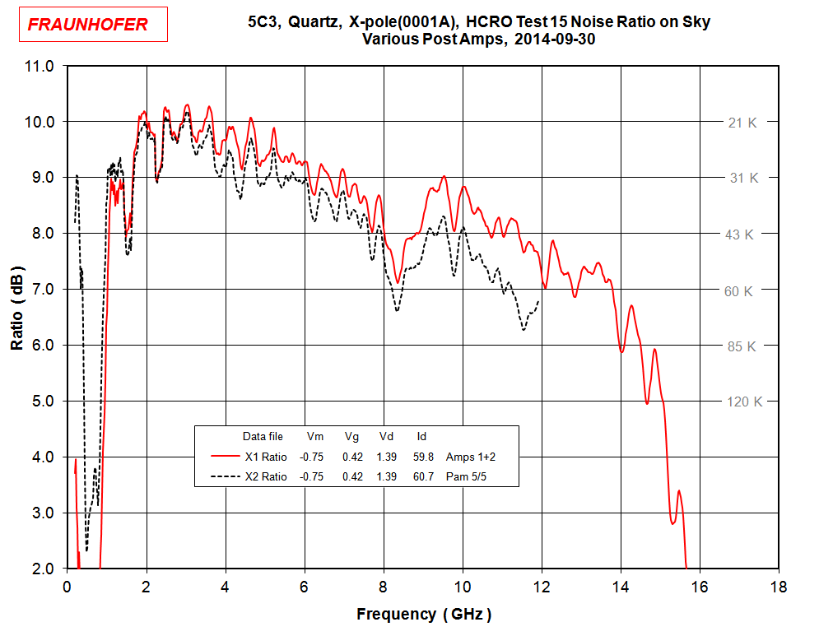

Figure 1 above

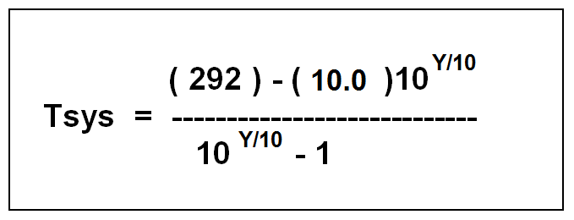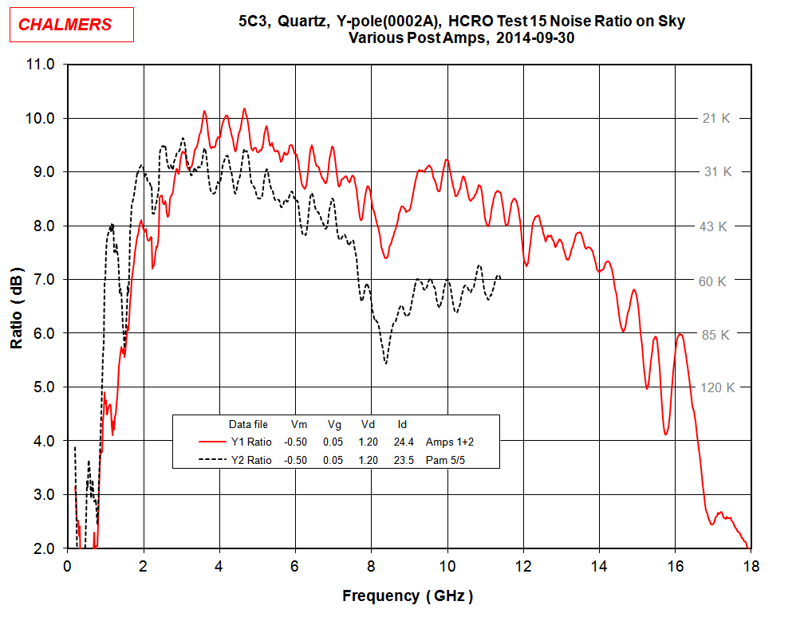

Figure 2

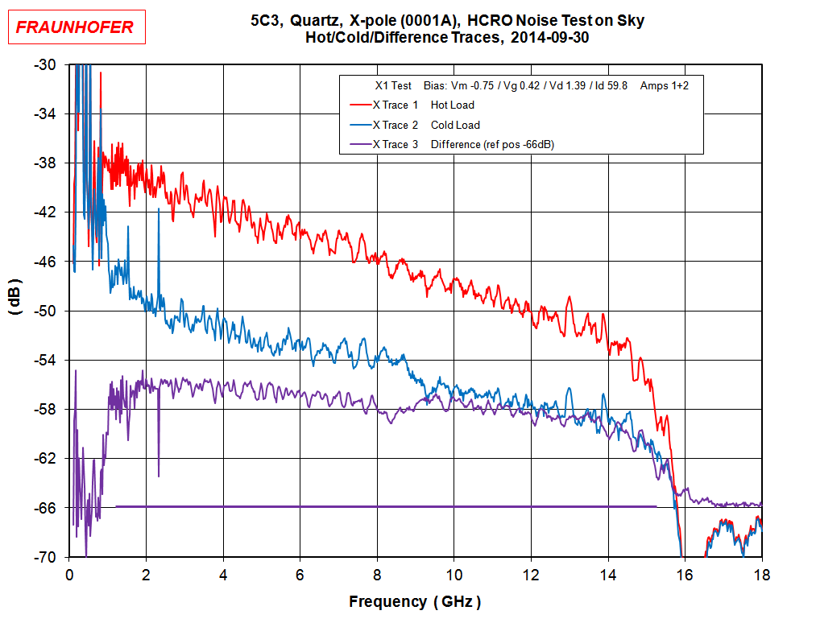

Figure 3 above

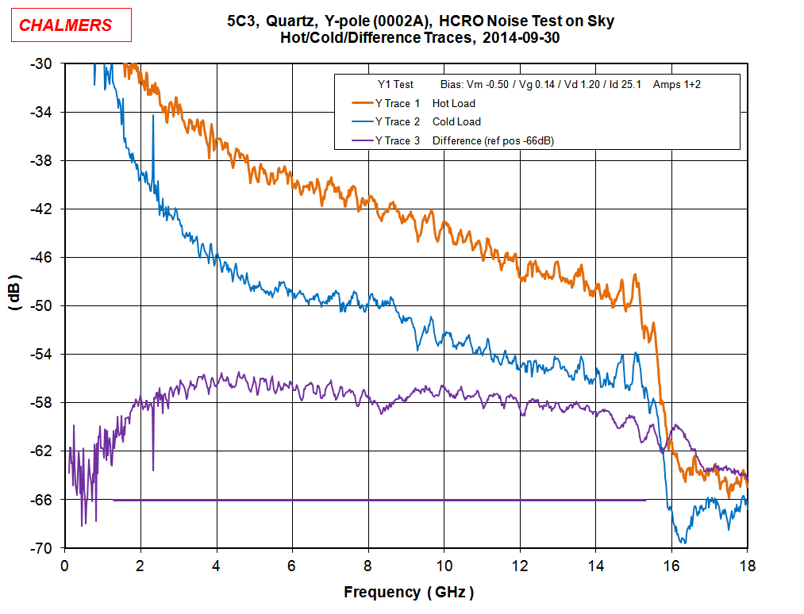

Figure 4

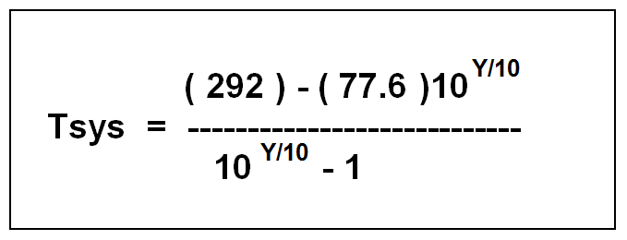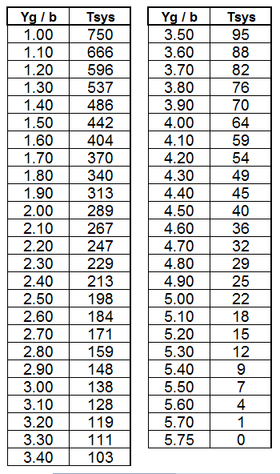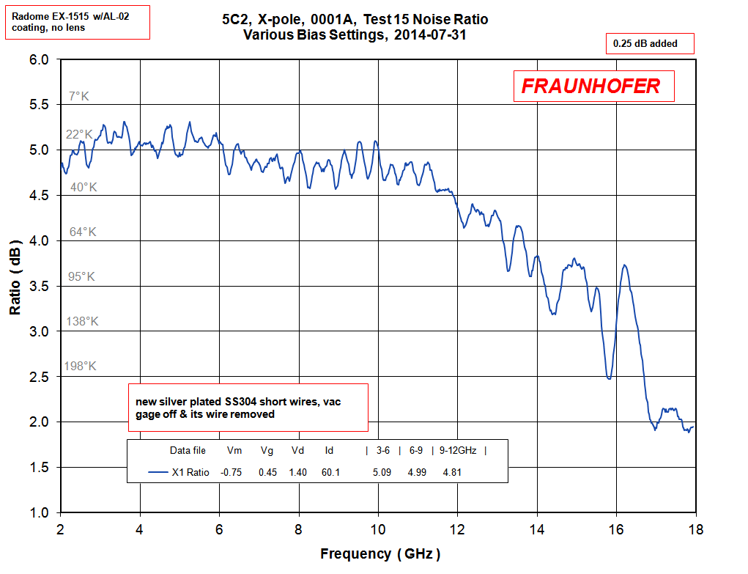

Figure 5 above

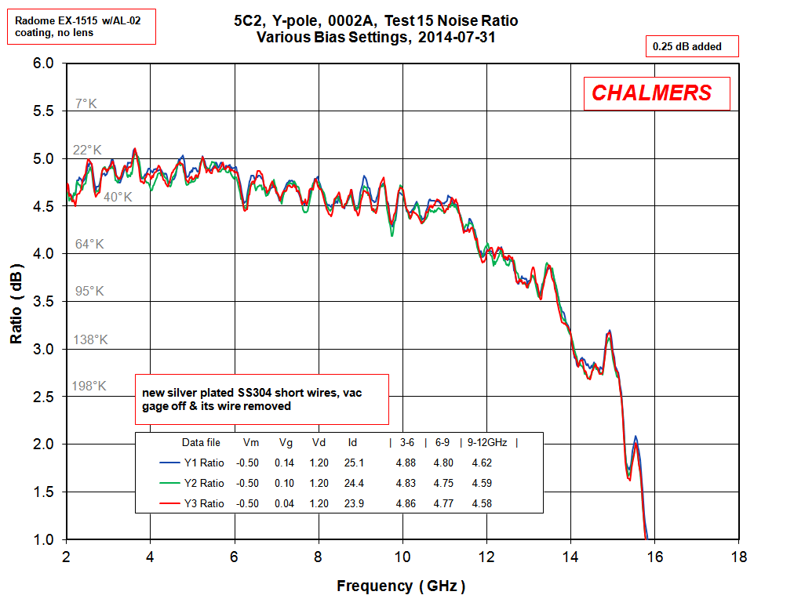

Figure 6